**CrowSoft**

Github

Git

|  |  |  |  |
| --- | --- | --- | --- |
| **Version** | **Date** | **Affected Sections(s)** | **Author** |
| 1.0 | 7/3/2019 | Initial Draft | Colin Kenny |
|  |  |  |  |

Table of Contents

Prerequisites 2

Set up 2

## Prerequisites

Install git to machine

Link:

<http://git-scm.com/download/win>

### Set up

GitHub project has been created

<https://github.com/rlennon/CrowSoft>

### Using Git

Create a folder for your workspace e.g. C:/CrowSoft

Open Git terminal

Change directory into newly created folder:

Cd CrowSoft

Clone down the repository:

git clone https://github.com/rlennon/CrowSoft.git

##### Set global parameters:

git config --global user.email [L000XXXXX@student.lyit.ie](mailto:L000XXXXX@student.lyit.ie)

git config --global user.name "L000XXXXX"

### Working Commands

git status New/Updated view files will be displayed in red.

git add –all Adds all files to staging area.

git commit -m "Add useful comment" Commits files with comment

git push -u origin master push changes to Master

git checkout CrowSoft-Document-Branch Checkout Branch

git push -u origin CrowSoft-Document-Branch Push to Branch - Current branch is the origin

git pull origin Pull to make sure your branch is up to date

rm -rf <folder_name> Remove Folder

git branch Display current branch

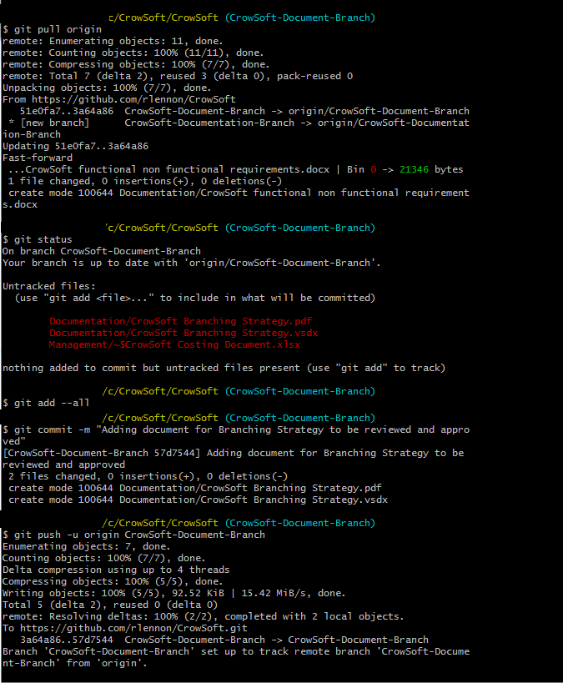

## Training:

<https://www.katacoda.com/courses/git>

<https://www.git-tower.com/blog/git-cheat-sheet/>

<https://datasift.github.io/gitflow/IntroducingGitFlow.html>